Prior Work and Influences

The United Kingdom government has been at the forefront of the open data movement, and among the available data, there have been a variety of applications created to visualize crime data. One of the first attempts we found was from a blog that described an app (Figure 1) that provided street-level crime data for each ward within a local authority district. It provided a map of the district and clicking on a ward provided a pie chart with information about the number and types of crimes in that area for a selected month. The blog post mentioned that there were ideas on combining crime data with related public sources, but unfortunately, the app and associated website are now defunct.

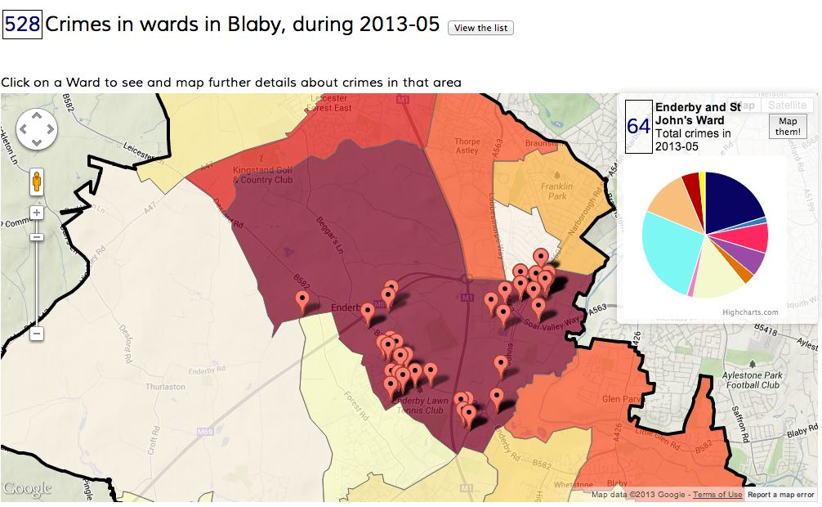

*Figure 1 – A screenshot of the now-defunct interactive application on crime data in England*

A very similar website[1] by the City of London Police maps the crime data and is filterable by crime type. Individual crimes can be viewed at the street level, and they offer basic statistics on the data over the most recent one-year period. However, the search is only provided by individual months and is limited to the City of London (Figure 2).

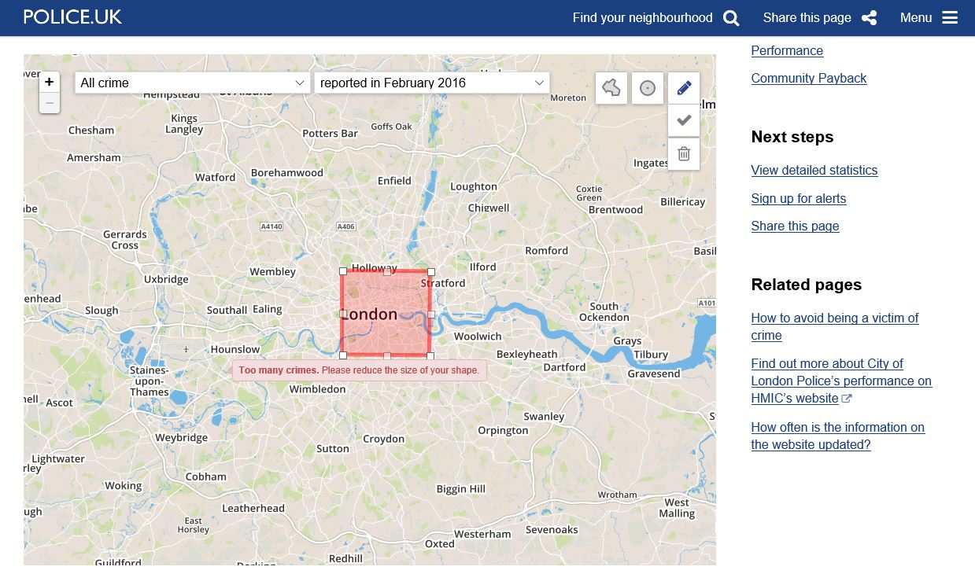

Figure 2 – A screenshot of the City of London Police website. The image is of the crime map section

Finally, one of the more impressive visualizations that we came across was not on crime data, but on information from the UK census[2] (Figure 3). There are several different levels of filtering, an impressive map that is mapped out down to the Lower-Layer Super Output Area (LSOA), and very robust data.

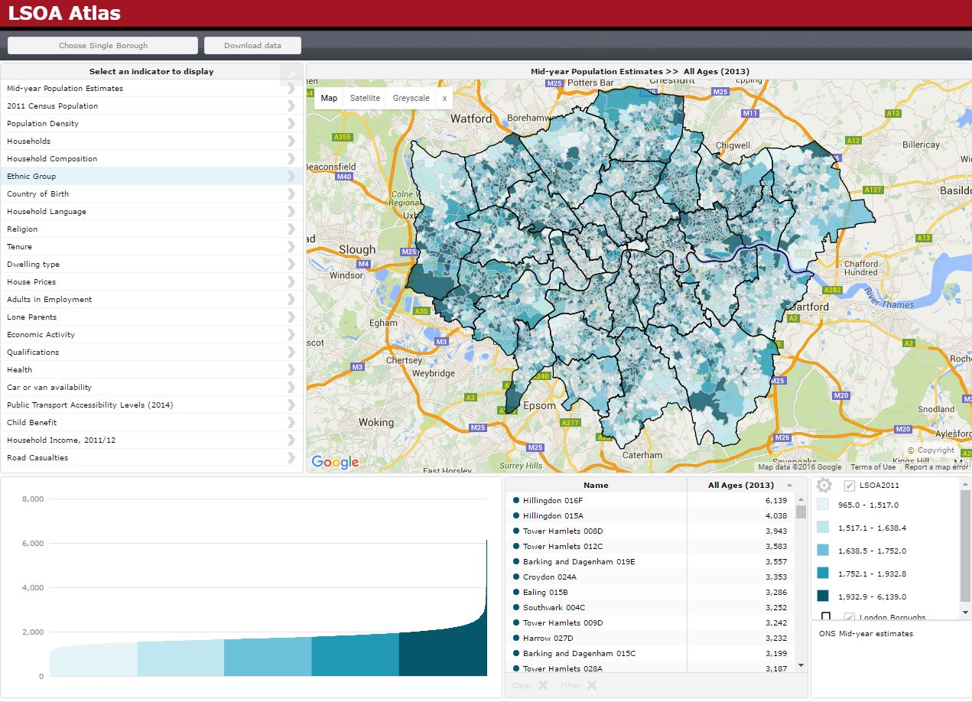

Figure 3 – A screenshot of the LSOA Atlas website which provides census information

These previous works, among others, provided stunning interactive visualizations, but they largely just relayed existing information. Our goal was to uncover new information by uniting these rich data sources.

Some prior research that influenced our work[3] incorporated the complex feedback between social and economic change in the domain of criminal justice, but also weaved in the political ideas of Thatcherism and its implications to their analyses. Our interpretations are strictly from the data at hand, without significant prior knowledge of British political history. Another source of inspiration was “The Economy, Crime and Time: An Analysis of Property Crime in England & Wales 1961-2006 (Jennings, Farrall, Bevan[4])” which provided a solid example of inferences and relationships between variables of crime, economy, and time in a time series regression model. The approached used in that study specifically focused on property crime.

1. "Crime Map." For Community Policing, City of London Police. Web. 12 May 2016. <https://www.police.uk/city-of-london/cp/crime/>.
2. "LSOA Atlas - 2011 Boundaries." L*SOA Atlas - 2011 Boundaries*. Web. 12 May 2016. <http://londondatastore-upload.s3.amazonaws.com/instant-atlas/lsoa-atlas/atlas.html>.
3. Farrall, Stephen, and Will Jennings. "Policy Feedback and the Criminal Justice Agenda: An Analysis of the Economy, Crime Rates, Politics and Public Opinion in Post-War Britain." *Contemporary British History* 26.4 (2012): 467-88. Web.
4. Jennings, Will, Stephen Farrall, and Shaun Bevan. "The Economy, Crime and Time: An Analysis of Recorded Property Crime in England & Wales 1961–2006." *International Journal of Law, Crime and Justice* 40.3 (2012): 192-210. Web.